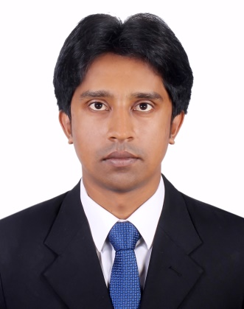**RESUME OF**

***Kazi Mahabub Khorshed***

Contact Address:

C/O: Md. Hossain Gazi

Block# B/5, Haque Residential Society

West Rajarbag, Sabujbag, Dhaka-1214.

Mobile No.: 01674041563

E-mail: mkhorshed88@gmail.com

**Career Objective:**Want to build up career in an organization that offers challenging opportunities to achieve the desire goal and that provides potential opportunities to become a goal-oriented person in the organization.

**Professional Experience:**

**1) Organization Name : Haque Brothers Industries Limited**

Location : 85/A, New Eskaton Road, Dhaka-1000.

Designation : Sales Officer

Duration : 22nd January 2007 to 31st December 2009.

**2) Organization Name : Meridian Foods Ltd.**

Location : House# 363, Road # 27, New DOHS Mohakhali, Dhaka.

Designation : Territory Sales Officer

Duration : 5th January 2010 to 31st December 2012.

**3) Organization Name : Compustar Private Ltd. (A Concern of Union Group)**

Location : House # 54, Road No # 11, Block-C, Banani, Dhaka-1213.

Designation : Territory Sales Executive

Duration : 20th February 2014 to 31st March 2015.

**4) Organization Name : Sky Telecommunication Ltd. (A joint venture of Partex Star**

**Group, Karnaphuli group, Metro Group))**

Location : Uday Tower (8th floor), Plot No. 57 & 57/A Gulshan-1,

Dhaka-1212.

Designation : Area Sales Manager

Duration : 2nd August 2015 to 31st December 2016.

**5) Organization Name : ACI Limited (Stylus Mobile)**

Location : Novo Tower, Level-2, 270, Tejgaon Industrial Area,

Dhaka-1208.

Designation : Area Sales Manager

Duration : 1st January 2017 to ill now.

**Educational Qualification:**

**Master of Business Administration (MBA)**

* Institution : Northern University Bangladesh
* Result : CGPA-3.313(Out of 4.00)
* Year of Passing : 2018
* Department : Marketing

**Master of Business Studies (M.B.S)**

* Institution : National University Bangladesh
* Result : Second Class
* Year of Passing : 2011
* Department : Management

**Bachelor of Business Studies (B.B.S)**

* Institution : National University Bangladesh
* Result : Second Class
* Year of Passing : 2010
* Department : Management

**Higher Secondary Certificate (HSC)**

* Institution : Govt. Shahid Suhrawardi College
* Result : GPA-3.30(Out of 5.00)
* Year of Passing : 2006
* Board : Dhaka
* Group : Business Studies

**Secondary School Certificate (SSC)**

* Institution : Kadamtala Purbo Bashabo High School
* Result : GPA-3.31(Out of 5.00)
* Year of Passing : 2004
* Board : Dhaka
* Group : Science

**Computer Literacy:**

* Application Package: MS Word, MS Excel, MS Power Point Etc.
* Others: Ability to work Internet & E-mail.

**Strengths & Abilities:**

* Moderately fluent in English & Bengali.
* Ability to work independently and in a team.
* Working within time and under pressure.
* Self-motivated, challenging, hard working, leadership quality, punctual, adaptive, friendly, president & honest.

**Personal Details**:

Father’s Name : Late Kazi Shahid Uddin

Mother’s Name : Azifa Begum

Permanent Address : Vill: Gonipur, P.O: Boroitola, P.S: Chandraganj, Dist: Laxmipur.

Nationality : Bangladeshi

Religion : Islam

Date of Birth : 03/11/1988

Marital Status : Married

Gender : Male

Blood : O+

­­­­­­­­­­­

______________________

**Kazi Mahabub Khorshed**